Implementation Specification
for
adopting caBIG Standards in caBIO

Release 4.1

Last Updated: February 15, 2008

Owner: caBIO Team
Email: klemmj@mail.nih.gov

National Cancer Institute Center for BioInformatics
6116 Executive Blvd.
Rockville, MD 20852



1 Document Purpose 3
2 Implementation Overview 4
2.1 Team Members 4
2.2 Description 4
2.3 Scope 4
2.3.1 Feature Requests 5
2.3.2 Defects 5
2.4 Use Cases 5
2.4.1 Gene Query 6
2.4.2 Protein Query 6
2.4.3 mRNA Query 7
2.5 Architecture 7
2.5.1 Existing Domain Model 7
2.5.2 Extended Domain Model 10
2.6 Data 12
2.7 Assumptions 12
2.8 Dependencies 12
2.9 Issues 12
2.10 Third Party Tools 13
3 Implementation Contents 14
3.1 Server 14
3.1.1 Algorithms 14
3.1.2 Batch Processes 14
3.1.3 APIs 14
3.1.4 Error Handling 14
3.1.5 Database Changes 14
3.2 Client 14
3.2.1 JSP/HTML 14
3.2.2 Servlet 14
3.2.3 Error Handling 14
3.3 Security Issues 14
3.4 Performance 15
3.5 Internationalization 15
3.6 Installation / Packaging 15
3.7 Migration 15
3.8 Documentation Considerations 15
4 Unit Testing 16
4.1 Test Guidelines 16
4.2 Test Cases 16
5 Data Exemplars 17
5.1 Data Exemplar for Gene, NucleicAcidSequence (including mRNA and EST) 17
5.2 Data Exemplar for Protein 17
DOCUMENT CONTROL 20
DOCUMENT APPROVAL 21

Document Purpose
This document provides design and implementation details that support use cases for adopting the caBIG Standards in caBIO. It describes the required caBIO domain object modeling and API changes.

Implementation Overview

Team Members

Role | Name
Director of Engineering | Avinash Shanbhag²
Internationalization Lead | N/A
Product Manager | Juli Klemm²
Project Manager | Sharon Gaheen¹
Test Lead | Ye Wu¹
Tech Lead | Jim Sun¹
Documentation Lead
Development Team | Konrad Rokicki¹  Lalitha Viswanath¹  Hong Dang³
¹ Science Applications International Corporation (SAIC)
² National Cancer Institute Center for Bioinformatics (NCICB)
³ Alpha-Gamma Technologies, Inc.
Table 1: Team Members

Description
In this version of caBIO we revisit the standards currently used to identify genes and proteins in caBIO and contrast the same with standards defined by the caBIG community. We then explore the recommended upgrades to caBIO to ensure compatibility with these standards.

Scope
This section addresses functionality that will be implemented by supporting the caBIG Standards.

The lack of a common genomic identifier in biomedical databases results in an interoperability problem in the caBIG™ environment. The question of how to deal with the problem of multiple identifiers (e.g. RefSeq ID, GenBank ID, Entrez Gene ID, Ensembl ID, UniProt ID) all pointing to the same object is addressed at the metadata level by the usage of 12 Genomic Identifier CDEs to identify Genomic Objects such as Genes, Proteins and Transcripts.

The following 12 identifiers are used to create caBIG-compatible CDEs for Genomic objects.
    - Ensembl Gene ID
    - Ensembl Transcript ID
    - Ensembl Peptide ID
    - Gene GenBank Accession Number
    - mRNA GenBank Accession Number
    - Gene GenBank Accession.Version
    - mRNA GenBank Accession.Version
    - Entrez Gene ID
    - RefSeq mRNA Accession Number
    - RefSeq Protein Accession Number
    - UniGene Cluster ID
    - UniProtKB Primary Accession Number

Further information the caBIG Standards is available at https://cabig.nci.nih.gov/workspaces/VCDE/Data_Standards/cde_alpha_gene

Adopting the caBIG Standards enables caBIO objects to be identified in a caBIG compatible form and enabling better interoperability with other caBIG-compatible systems.

Feature Requests
Request ID | Summary | Description
GF4208 | Fix the caBIO Gene Object to use the caBIG standard for Gene | The caBIG community has defined a gene object after the caBIO domain objects. Change the model in the 4.0 release.
GF8427 | Modify the caBIO 4.0 model to use the caBIG standards | Same as above.  It’s redundant to GF4208. Listed for completeness

Defects
N/A

Use Cases
The use cases described here are from the system perspective, and greatly generalized. The Use cases for “Gene Query” and “Protein Query” have already implemented and available in caBIO 4.0 release. They are added here for completeness.

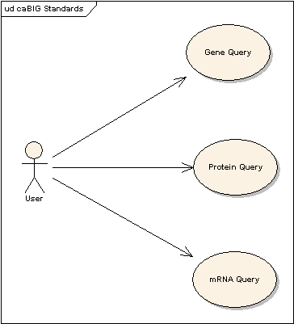
Figure 1: Use Case Diagram

Gene Query

Use Case Name | Gene Query
Use Case ID | 1.1
Primary Actor | Public
Brief Description | Allows users to find caBIO genes using caBIG-compatible identifiers.
Trigger | The user wants to search for genes of interest.
Pre-conditions | - The user navigates to the caBIO Home Page and clicks “Continue”
Flow of Events | - The user selects the Gene object  - The user pastes in a caBIG-compatible Id into the identifier field  - The user clicks the submit button to initiate the search  - A list of Genes appears  - The user can obtain further details of each gene by clicking on the respective association links
Post Conditions | Success Condition: The user successfully searches the database using a caBIG compatible Identifier and obtains the list of Genes.  Error Conditions:  EC1: System Error during Request Processing  EC2: Specified Id does not exist  EC3: Specified Id does not identify a valid gene
Alternative Flow | Alternate Condition:  AC2: No result is found  1. “No results found” message is displayed
Related Use Cases | Protein Query, mRNA Query
Issues/Notes | - The user can also execute the same search using the Java API or Web Service

Protein Query

Use Case Name | Protein Query
Use Case ID | 1.2
Primary Actor | Public
Brief Description | Allows users to find proteins using a caBIG compatible protein identifier.
Trigger | The user wants to search for proteins of interest.
Pre-conditions | - The user navigates to the caBIO Home Page and clicks “Continue”
Flow of Events | - The user selects the Protein object  - The user provides a caBIG compatible protein identifier in the id field  - The user clicks the submit button to initiate the search  - A list of Proteins appears  - The user can obtain further details of each protein by clicking on the respective association links
Post Conditions | Success Condition: The user successfully searches the database and obtains the list  Error Conditions:  EC1: System Error during Request Processing  EC2: Specified Id does not exist  EC3: Specified Id does not identify a valid protein
Alternative Flow | Alternate Condition:  AC2: No result is found  1. “No results found” message is displayed
Related Use Cases | Gene Query and mRNA Query
Issues/Notes | - The user can also execute the same search using the Java API or Web Service.

mRNA Query

Use Case Name | mRNA Query
Use Case ID | 1.3
Primary Actor | Public
Brief Description | Allows users to find mRNAs/transcripts using a caBIG compatible Mrna/transcript identifiers such as GenBank Accession Number, mRNA GenBank Accession Number and RefSeq mRNA Accession Number .
Trigger | The user wants to search for transcripts of interest using a caBIG compatible identifier.
Pre-conditions | The user navigates to the caBIO Home Page and clicks “Continue”
Flow of Events | - The user selects the NucleicAcidSequence object  - The user provides a caBIG compatible identifier in the id field  - The user clicks the submit button to initiate the search  - A list of NucleicAcidSequence appears  - The user can obtain further details of each NucleicAcideSquence by clicking on the respective association links
Post Conditions | See Gene Query and Protein Query
Alternative Flow | See Gene Query and Protein Query
Related Use Cases | See Gene Query and Protein Query
Issues/Notes | See Gene Query and Protein Query

A caBIG compatible object is any Genomic object that can be identified using one or more of the caBIG-recommended identifier.

The various use cases boil down to ensuring that Genomic Objects such as Gene, Protein and mRNA are identifiable by caBIG compatible Identifiers provided earlier, and adding new objects for the same if required.

Architecture
The implementation will use the standard SDK generated system. No API changes are required.
The caBIG-standards modeling implementation will use the standard SDK generated system. The following caBIO domain model is used to store the genomic objects and associated information.

Existing Domain Model
caBIO has three primary Genomic objects, Genes, Proteins and NucleicAcidSequence. The following domain model is currently in place for these Genomic Objects in caBIO. These objects are described in further detail in Table 1 below
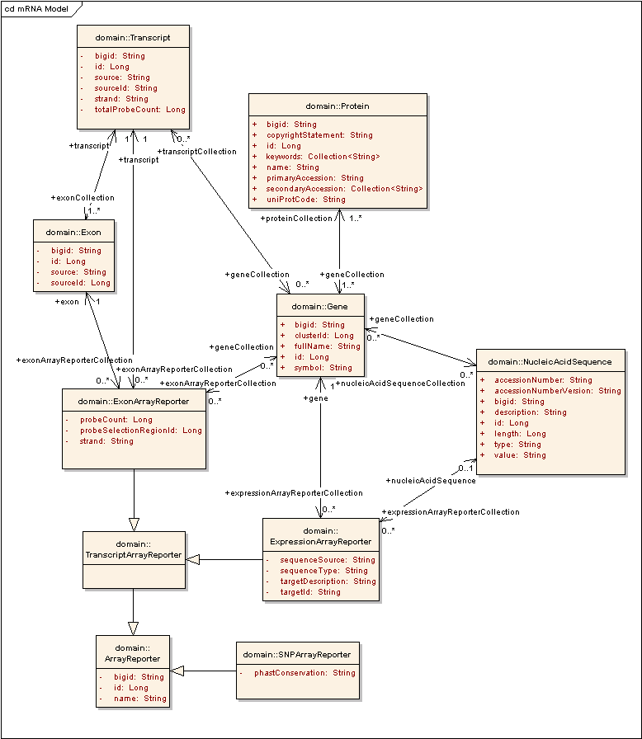

Figure 1: caBIG NucleicAcidSequence object in caBIO 4.0

caBIO Domain Object
Gene | Gene objects are the effective portal to most of the genomic information provided by the caBIO data services; organs, diseases, chromosomes, pathways, and sequence data are among the many objects accessible via a gene. caBIO currently obtains this data from Unigene and exposes the Unigene Cluster Id through Gene.ClusterId for all 194911 genes. Entrez Gene Ids, available for 59789 genes are exposed through DatabaseCrossReference. Ensembl Gene Ids available for 31707 genes are also exposed via DatabaseCrossReference. Of the 195911 Unigene clusters in caBIO, 3903 Unigene Clusters map to multiple genes.
Protein | An object representation of a protein; provides access to the encoding Gene via its GenBank ID, apart from providing the Taxon in which this instance of the protein occurs. It gets populated with data from Uniprot-Swissprot.  All 31288 caBIO Proteins can be uniquely identified using a Uniprot Accession Number. RefSeq Protein Accession Numbers are available for 15776 caBIO Proteins in DatabaseCrossReference.CrossReferenceId
NucleicAcidSequence | An object representation of a gene sequence; provides access to the clones from which it was derived, the ASCII representation of the residues it contains, and the sequence ID. CaBIO obtains NucleicAcidSequence information from NCBI’s Unigene data and currently exposes the 10.8 million EST and mRNA sequences that are used to construct Unigene. Each sequence is identified either by the Genbank Accession Number or the RefSeq Accession Number, with 55,000 being RefSeq identifiers.
Transcript | This object is created from Affymetrix’s transcript annotation file. It consists of a number of Exons. The current Transcript object is a collection of exons used to model the probes in Affymetrix Exon Arrays. Hence this object cannot be made caBIG compatible.
Exon | This object is created from Affymetrix’s Exon probes set annotation file. It is currently only used for grouping ExonReporters.
ExonReporter | A reporter class for supporting Exon-based array probesets.
SNPReporter | A reporter class for genotyping arrays such as Affymetrix Mapping (SNP) arrays and Illumina’s 550K.

Table 1. Description of Genomic objects and other related objects in the current caBIO model.

Table 2 shows the inter-relationship between the caBIG identifiers and caBIO.

Ca-BIG compatible Identifier | Relevant Genomic Object | Available in caBIO? | API Access
Unigene Cluster Id | Gene | Yes | Gene.ClusterId
Entrez Gene Id | Gene | Yes | DatabaseCrossReference.CrossReferenceId
Ensembl Gene Id | Gene | Yes | DatabaseCrossReference.CrossReferenceId
RefSeq Gene Id | Gene | No | N/A
UniprotKB Accession Number | Protein | Yes | Protein.PrimaryAccession
RefSeq Protein Id | Protein | Yes | DatabaseCrossReference.CrossReferenceId
Ensembl Peptide Id | Protein | No | N/A
RefSeq mRNA accession number | mRNA | Yes | NucleicAcidSequence.AccessionNumber
mRNA GenBank Accession.Version | mRNA | Yes | NucleicAcidSequence.AccessionNumber  +NucleicAcidSequence.AccessionNumberVersion
mRNA Genbank Accession Number | mRNA | Yes | NucleicAcidSequence.AccessionNumber
mRNA GenBank Accession.Version | mRNA | Yes | NucleicAcidSequence.AccessionNumber  +NucleicAcidSequence.AccessionNumberVersion
Ensembl Transcript Id | mRNA | No | N/A

Based on the above, there are 2 caBIG-compatible objects in the 4.0 caBIO domain model. i.e. Gene and Protein.

The NucleicAcidSequence object in the current model needs to be extended to accommodate the proposed Mrna and EST objects to ensure complete caBIG Standards compatibility.

Extended Domain Model
The new model is shown in Figure 2. The main changes are:

- A subclass of NucleicAcidSequence for each of the two types of NucleicAcidSequence (namely, EST and mRNA) using the table-per-class-hierarchy modeling method.

There are several benefits to this change. When a user is holding a NucleicAcidSequence object, they know immediately (by the object’s actual class) what kind of object is being retrieved, whether it is mRNA or an EST. This could form the basis for selective retrieval of physical locations for a NucleicAcidSequence if required.

In the current model, NucleicAcidSequence.type stores the type of sequence ‘2’ referring to an EST and ‘1’ an Mrna. This would be deprecated in future releases. A new column ‘DISCRIMINATOR’ would be added to distinguish the two types of sequences. This would form the basis for identifying the subclasses of NucleicAcidSequence.

To be more consistant with the caBIO domain modeling naming convention, mRNA and EST classes will be named as MessengerRNA and ExpressedSequenceTag as shown in the diagrams below.
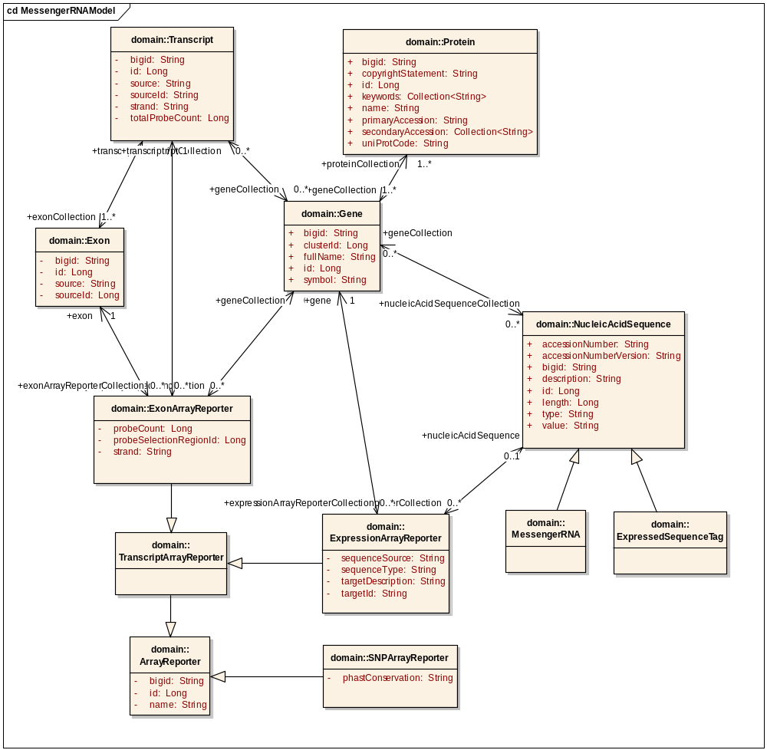

Figure 2: caBIG-compatible objects in caBIO 4.1

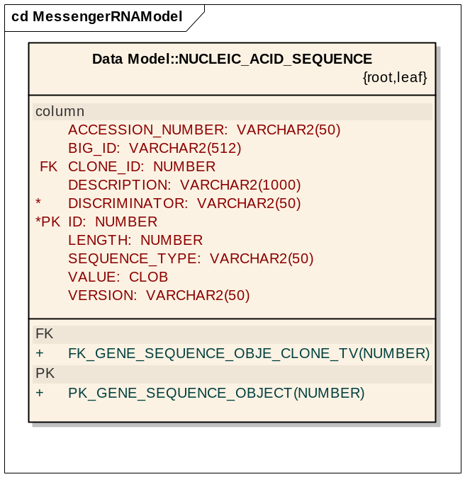

Figure 2: Corresponding database table for Nucleic_Acid_Sequence in caBIO 4.1

Data
The system currently obtains the data for the Gene object from NCBI’s Unigene, which will continue to be available through the Gene object in the modified model.

The sequences used to create the Unigene clusters will be available through NucleicAcidSequence as before. Additionally, the transcript sequences would be available through the new mRNA object while the ESTs would be available through the EST objects.

Assumptions
- The SDK will correctly support table-per-class-hierarchy mapping

In the past, class hierarchies have been kept to a minimum in caBIO because of the way the SDK mapped them onto the underlying database. The current strategy is called table-per-subclass, and involves joining to all of the sub-classes and super-classes of a given class when querying on that class. For this new modeling to be successful, we assume that we can use a new feature of the SDK 4.0 to generate efficient table-per-class-hierarchy mappings which do not need joins.

Dependencies
The caBIO system is dependent on the caCORE SDK, version 4.0 or higher.

Issues
There are no known issues at this time.

Third Party Tools
The API will use the caCORE SDK. See the current SDK technology stack for a complete listing.

Implementation Contents

Server
The caBIO server will run in the standard JBoss configuration. This implementation affects only the modeling and database, not the server configuration.

Algorithms
See APIs section below.

Batch Processes
None expected.

APIs
The standard caBIO domain model.

Error Handling
The standard SDK Error Handling will be used. See the SDK Exception handling documentation for more information.

Database Changes
As discussed in the Assumptions section, the new modeling is predicated upon a table-per-class-hierarchy mapping at the ORM and database levels. On the database side, the subclass tables will be created as normal to allow for backwards compatibility. However, the NucleicAcidSequenc’s type attribute will now function as a CLASS DISCRIMINATOR column required by the SDK and Hibernate. This column would now indicate the class for each NucleicAcidSequence with the names being ‘MessengerRNA’ or ‘ExpressedSequenceTag’ based on the sequence type.

These discriminator columns will be mapped to objects in the EA model as per the SDK 4.0 Developer’s Guide.

Client
The standard SDK generated client will be used for this implementation

JSP/HTML
The standard SDK generated JSP/HTML interface will be used for this implementation

Servlet
The standard SDK generated Servlet will be used for this implementation

Error Handling
The standard SDK Error Handling will be used. See the SDK Exception handling documentation for more information.

Security Issues
The location data is publicly available and does not require any security.

Performance
The performance of the system, after the changes herein are completed, shall be at least equal to the previous version.

Internationalization
Not applicable.

Installation / Packaging
The design assumes the standard caBIO installation and packaging.

Migration
N/A

Documentation Considerations
- This design document
- Updated caBIO Technical Guide
- SDK 4.0 Developer’s Guide

Unit Testing

Test Guidelines
Unit tests for the Java API are part of the cabioapi repository, and are run as part of the daily build.
New test cases that would validate associations between NucleicAcidSequence and other classes, as per the model would be added to the test suite.

Test Cases
Each method in the new API shall be tested with several exemplars. An example would be the association between NucleicAcidPhysicalLocation and Mrna/EST

Data Exemplars

Data Exemplar for Gene, NucleicAcidSequence (including mRNA and EST)
GENE | NAT2 | Gene.Symbol
CYTOBAND | 8p22 | Used to obtain CytogeneticLocations
GENE_ID | 10 | Refer LocusLink
LOCUSLINK | 10 | DatabaseCrossReference
HOMOL | YES | -
RESTR_EXPR | adult | -
CHROMOSOME | 8 | Used to map to Chromosome
STS | ACC=PMC310725P3 UNISTS=272646 | -
STS | ACC=WIAF-2120 UNISTS=44576 | -
STS | ACC=G59899 UNISTS=137181 | -
STS | ACC=G06461 UNISTS=17088 | -
STS | ACC=GDB 310612 UNISTS=156422 | -
STS | ACC=GDB 310613 UNISTS=156423 | -
STS | ACC=GDB 187676 UNISTS=155563 | -
SCOUNT | 38 | -
SEQUENCE | ACC=BC067218.1; NID=g45501306;  PID=g45501307; SEQTYPE=mRNA | NucleicAcidSequence.AccessionNumber  -  -  NucleicAcidSequence.Discriminator
SEQUENCE | ACC=BG569293.1; NID=g13576946;  CLONE=IMAGE 4722596; END=5';  LID=6989;  SEQTYPE=EST; TRACE=44157214 | NucleicAcidSequence.AccessionNumber  NucleicAcidSequence.Discriminator
SEQUENCE | ACC=AI792606.1;  NID=g5340322;  CLONE=IMAGE 1870937; END=5';  LID=1079;  SEQTYPE=EST | NucleicAcidSequence.AccessionNumber  NucleicAcidSequence.Discriminator

Data Exemplar for Protein
ID | 104K_THEAN Reviewed; 893 AA.
AC | Q4U9M9; | Protein.PrimaryAccession
DT | 18-APR-2006, integrated into UniProtKB/Swiss-Prot. | -
DE | 104 kDa microneme/rhoptry antigen precursor (p104). | Used to build ProteinAlias
GN | ORFNames=TA08425; | -
OS | Theileria annulata. | -
OC | Eukaryota; Alveolata; Apicomplexa; Aconoidasida; Piroplasmida; | -
OC | Theileriidae; Theileria. | -
OX | NCBI_TaxID=5874; | Used to map to the appropriate Taxon
RN | [1] | -
RP | NUCLEOTIDE SEQUENCE [LARGE SCALE GENOMIC DNA]. | -
RC | STRAIN=Ankara; | -
RX | PubMed=15994557; DOI=10.1126/science.1110418; | -
RA | Pain A., Renauld H., Berriman M., Murphy L., Yeats C.A., Weir W., | -
RT | "Genome of the host-cell transforming parasite Theileria annulata | -
RT | compared with T. parva."; | -
RL | Science 309:131-133(2005). | -
CC | -!- SUBCELLULAR LOCATION: Cell membrane; Lipid-anchor, GPI-anchor | Protein_Copyright
CC | (Potential). Note=In microneme/rhoptry complexes (By similarity). | Protein_Copyright
CC | Copyrighted by the UniProt Consortium, see http://www.uniprot.org/terms | Protein_Copyright
CC | Distributed under the Creative Commons Attribution-NoDerivs License | Protein_Copyright
DR | EMBL; CR940353;  CAI76474.1;  -;  Genomic_DNA. | Used to extract EMBL Ids (PROTEIN_EMBL)
DR | KEGG;  tan:TA08425; -. | -
DR | InterPro; IPR007480; DUF529. | -
DR | Pfam; PF04385; FAINT; 4. | -
FT | SIGNAL 1 19 Potential. | -
FT | CHAIN 20 873 104 kDa microneme/rhoptry antigen. | -
FT | /FTId=PRO_0000232680. | -
FT | PROPEP 874 893 Removed in mature form (Potential). | -
FT | /FTId=PRO_0000232681 | -
FT | COMPBIAS 215 220 Poly-Leu. | -
FT | COMPBIAS 486 683 Lys-rich. | -
FT | COMPBIAS 854 859 Poly-Arg. | -
FT | LIPID 873 873 GPI-anchor amidated aspartate | -
SQ | SEQUENCE 893 AA;  101921 MW;  2F67CEB3B02E7AC1 CRC64;  MKFLVLLFNI LCLFPILGAD ELVMSPIPTT DVQPKVTFDI NSEVSSGPLY LNPVEMAGVK YLQLQRQPGV QVHKVVEGDI VIWENEEMPL YTCAIVTQNE VPYMAYVELL EDPDLIFFLK EGDQWAPIPE DQYLARLQQL RQQIHTESFF SLNLSFQHEN YKYEMVSSFQ HSIKMVVFTP KNGHICKMVY DKNIRIFKAL YNEYVTSVIG FFRGLKLLLL NIFVIDDRGM IGNKYFQLLD | Protein.length  Protein.molecularWeight  Protein.sequence
DOCUMENT CONTROL
Change History
Content changes to this document from the previous to the current level are indicated by revision bars (|) unless a complete rewrite is indicated.

Table 2 – Implementation Specification Document Change Log
Version/Date | Approved By | Change Description and Explanation | D - Draft  A - For Review/ Approval  R - Re-Approval, Plan of Record Change
11/16/2007 | Lalitha Viswanath | Initial revision | D
11/16/2007 | Jim Sun | Updated mRNA use case  Updated the feature requests  Added the reference section at the end | A
12/26/2007 | Jim Sun | Update the subclasses names with MessengerRNA (mRNA) and ExpressedSequenceTag (EST) so it is more conforming to caBIO modeling naming convention. | R
Note: If this document has been inspected, please indicate the inspection date that each version is based on in the “Change Description and Explanation” area. Entries in this log must be maintained for at least 3 years.

References:

Date | Title | Version | Author
12/21/2005 | Documentation of Genomic Identifier | Ver. 1.1 | Vishal K. Nayak
10/30/2007 | caBIO 4.0 Technical Guide | NA
10/10/2007 | caCORE SDK Developers’ Guide | NA

DOCUMENT APPROVAL
Approvers List
The individuals listed in this section constitute the approvers list for the Integration Test Plan document. Formal approval must be received from all approvers prior to the initiation of the next steps in the process.

Title | Name
Project Manager | Name
Development Manager | Name

Reviewers List
The individuals listed in this section constitute the reviewers list for the Master Test Plan document. Formal approval is not required from the reviewers, however, it is desirable to have all reviewers review and comment on the document. Reviewers may choose to concentrate on reviewing only those sections that are in their area of responsibility, rather than the entire document.

Title | Name
Solutions Manager | Name
Project Manager | Name
Test Manager | Name
Test Engineer | Name
Development Manager | Name
Technical Writer | Name
Client Support Analyst | Name
Internationalization Lead | Name
DBA | Name
Developer | Name
Developer | Name

END OF DOCUMENT

